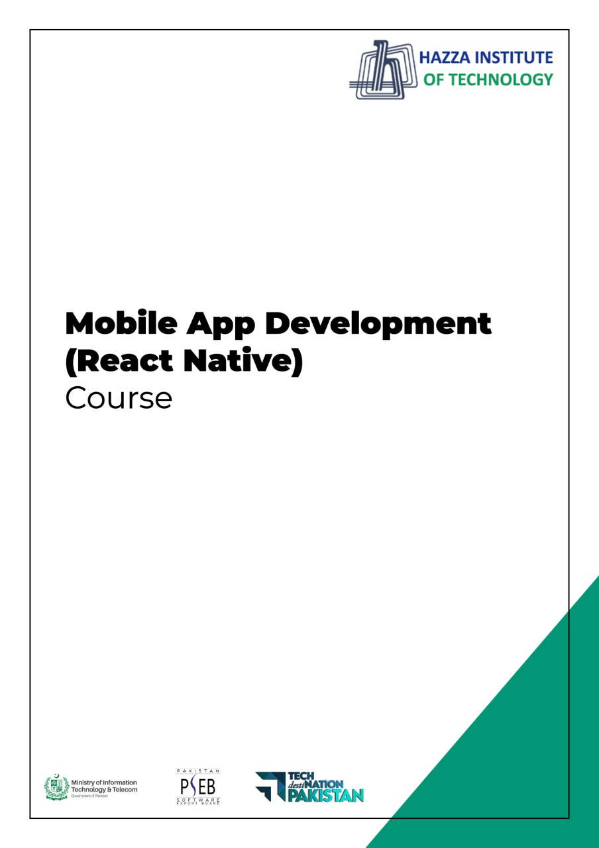

**(React Native)**

Final Paper

**Final Term PAPER**

Total Marks; 100

Q1: Answer the Following MCQs. (20 Marks)

1. Which statement is true for props?

* can be modified
* can’t be modified
* it is mutual
* it is set and updated by the object

1. Props are immutable. True or False?

* TRUE
* FALSE

3. ________is used to create immutable stylesheet references

* Redux
* none
* stylesheet
* Interaction manager

4. Virtual DOM creates a copy of the whole DOM object

* FALSE
* TRUE

5. JSX stands for

* JointScript XML
* JavaScript XML
* JavaScreenXML
* None

6. Can we use React native for web?

* Yes
* No

7. To update react native with latest version what will you use?

* react-native init
* react-native upgrade
* none
* both

8. React native was initially released in

* 2008
* 2015
* 2000
* 2014

9. Select apps which used react native .

* Airbnb
* pinterest
* Instagram
* All

10. Select the correct statement about uncontrolled components.

* It maintains its internal states
* data is controlled by the DOM itself
* A ref is used for their current values
* All

Q2: List the essential components of React Native? (20 Marks)

Q3: How many types of threads are in React Native? (20 Marks)

Q4: Why do we use StyleSheet.create? What are the tradeoffs with this approach? (20 Marks)

Q5: Can we combine native codes of Android and iOS in React Native? (20 Marks)

**END**